Creating HTML Templates

1. Create a file with convention <name>.html

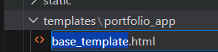

1. Edit file with notepad, VSCode or any other text editor
   1. Markup tags: [HTML Cheat Sheet - Learn web development | MDN (mozilla.org)](https://developer.mozilla.org/en-US/docs/Learn/HTML/Cheatsheet)
   2. HTML docs typically start with <!DOCTYPE html>
   3. Make sure to check open (i.e. <head>) and end (i.e. </head>) tags
   4. { % thing % } is replaced by item named thing from the django project settings.py (if it won’t work, make sure to check spelling on variable and if it exists to replace item)

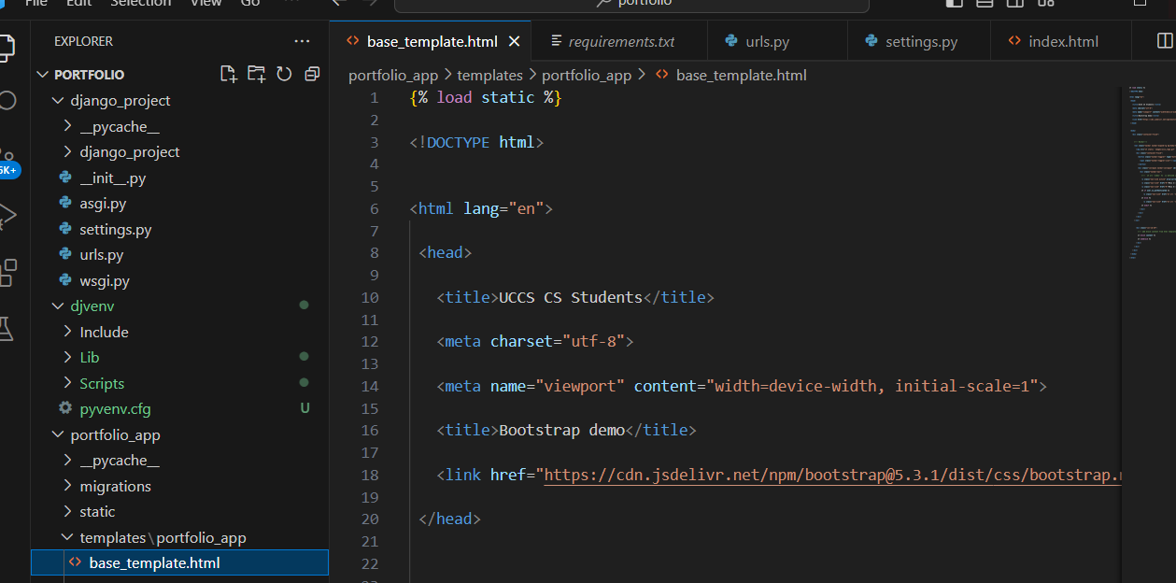

Extras:

* HTML checkers can help find syntax errors for you (django syntax not always supported)